AeroBrigham delivers state of the art Law Enforcement Bell 407 to Marion Cty. Florida
AeroBrigham pulled out all the stops to enhance Marion’s capabilities to protect and serve its more than 1,600 square miles. Our customer wanted nothing but the best interfaced technology to reduce the workload of both the pilot and TFO. Garmin G500 synthetic vision, Rad alt and video enabled, ESI 500, GTN650, HTAWS and moving maps all interfaced. FLIR380 HDC tied to the Churchill Nav and triple macro blue monitors; two in the front and one in the cabin for superior training capabilities. Hoist camera displayed on the G500, coupled with NVIS approved lighting, a cargo hook, floats, bambi bucket and hoist installations round out all the utility components a true work horse law enforcement helicopter requires.
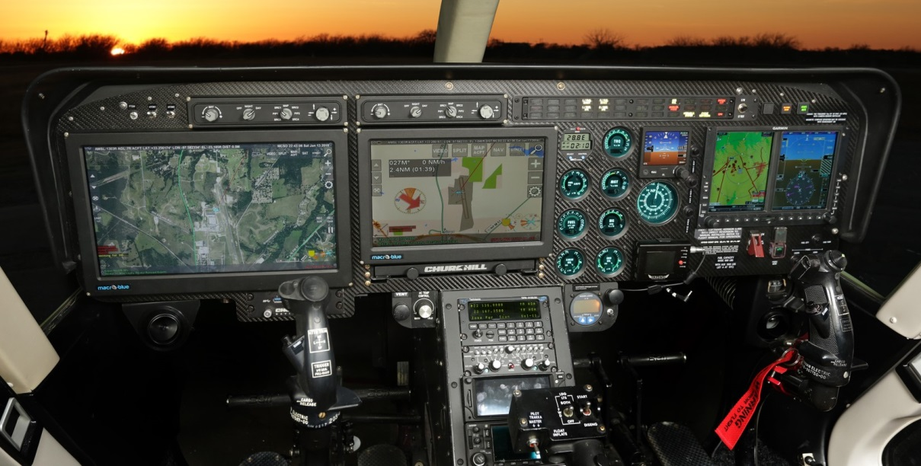
Visit AeroBrigham at Booth N3530 to be inspired by their quality of workmanship on another recently delivered Bell 407. AeroBrigham is located at the Decatur Municipal Airport (KLUD) in Decatur Texas just north of DFW airport. FAA Repair Station 1YJR859C.

